**DAILY ONLINE ACTIVITIES SUMMARY**

|  |  |  |  |  |  |  |  |  |
| --- | --- | --- | --- | --- | --- | --- | --- | --- |
| **Date:** | 20/05/2020 | | | | | **Name:** | CHANDANA S | |
| **Sem & Sec** | 4TH&A | | | | | **USN:** | 4AL18CS016 | |
| **Online Test Summary** | | | | | | | | |
| **Subject** | | Object Oriented Concepts | | | | | | |
| **Max. Marks** | | 30 | | **Score** | | | 17 | |
| **Certification Course Summary** | | | | | | | | |
| **Course** | Python for machine learning | | | | | | | |
| **Certificate Provider** | | | Great learning | | **Duration** | | | 1 Hours |
| **Coding Challenges** | | | | | | | | |
| **Problem Statement:** 1. Write a C Program to Reverse a Linked List (SLL) in groups of given size.  2. To find the duplicate number from the array | | | | | | | | |
| **Status:** Completed | | | | | | | | |
| **Uploaded the report in Github** | | | | | YES | | | |
| **If yes Repository name** | | | | | <https://github.com/chandushivalingareddy/lockdown-coding> | | | |
| **Uploaded the report in slack** | | | | | YES | | | |

**Online Test Details:**

The online test was from module 1 which was about Introduction to object-oriented concepts. There were 30 questions which lasted for 30 minutes. The questions were easy. I scored 17 out of 30.

**Snapshot**:

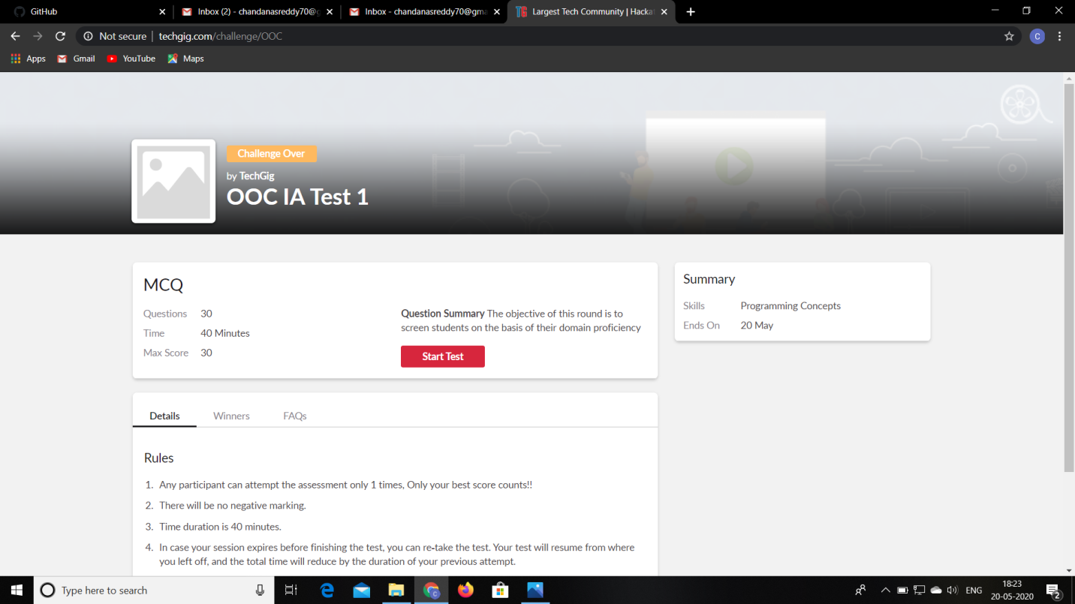

**Certification Course Details:**

**Name of the course**: Python for machine learning

**Certificate Provider**: Great learning

This course has 19 sections and the total duration is 24 hours.

In the third day I went through the second section of the course and learnt the different data structures available in python and heir usages.

**Snapshot:**

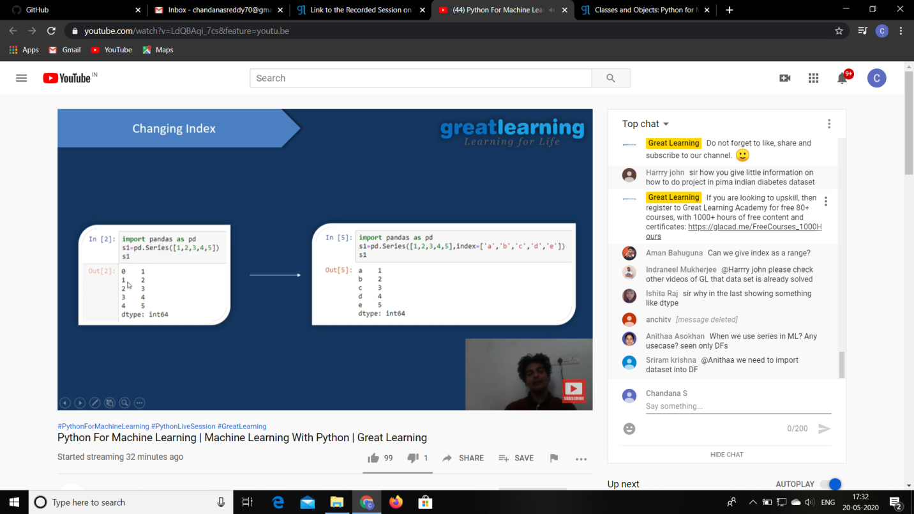

**Online Coding Details:**

|  |
| --- |
| Test Case 1: If a linked list is: 1 → 2 → 3 → 4 → 5 → 6 → 7 → 8 The value of size k is 2 Then the linked list looks like: 2 → 1 → 4 → 3 → 6 → 5 → 8 → 7  Test Case 2: If a linked list is: 1 → 2 → 3 → 4 → 5 → 6 → 7 → 8 The value of size k is 3 Then the linked list looks like: 3 → 2 → 1 → 6 → 5 → 4 → 8 → 7 |

Problem 1: (using C language) [Write a C Program to Reverse a Linked List (SLL) in groups of given size.](https://github.com/orgs/alvas-education-foundation/teams/2nd-year/discussions/67)

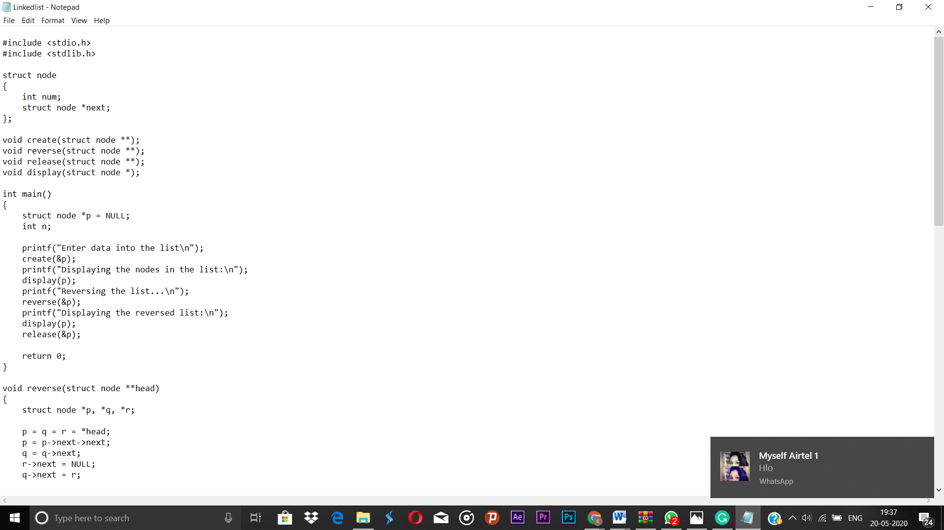Top of Form

Bottom of Form



Problem 2: (Using JAVA) Given an array a[] of size n which contains elements from 0 to n-1, write a program print Duplicates which prints the duplicate elements of the given array. If no duplicate element is found print -1.  
Input:  
The first line of input must contains an integer n which denotes number of elements of Array. Second line contains n space separated integers denoting elements of array a[].

Output:  
Print the duplicate elements from the given array

